**Technical Assessment Questions**

***Instructions:***

* Candidate need to write test automation script based on the scenario as detailed in the question(preferably can be run in visual studio code).
* Candidate must include a “readme” file on how to run the test script.
* The script can be written in any language and using any tools.
* Once the script successfully run, please upload the script along with the report in candidate’s own git page.

**Q1:**

* Navigate to <https://www.globalsqa.com/angularJs-protractor/BankingProject/#/login>.
* Login as Bank Manager and create customers as below:

|  |  |  |
| --- | --- | --- |
| **First Name** | **Last Name** | **Postcode** |
| Christopher | Connely | L789C349 |
| Frank | Christopher | A897N450 |
| Christopher | Minka | M098Q585 |
| Connely | Jackson | L789C349 |
| Jackson | Frank | L789C349 |
| Minka | Jackson | A897N450 |
| Jackson | Connely | L789C349 |

* Go to Customers Tab ,Verify all the customers are inserted in the table.
* Delete specific customers122:

|  |  |  |
| --- | --- | --- |
| **First Name** | **Last Name** | **Postcode** |
| Jackson | Frank | L789C349 |
| Christopher | Connely | L789C349 |

**Q2:**

* Navigate to <https://www.globalsqa.com/angularJs-protractor/BankingProject/#/login>.
* Click Customer Login.
* Choose **Your Name as Hermoine Granger and Login.**
* Choose **“1003”**  in the drop down.
* Perform debit and credit transaction as above. Using calculation, Determine current balance of the account after each transaction. Verify the current balance is tally with Balance section in the Customer Homepage.

**Transaction:**

|  |  |  |
| --- | --- | --- |
| Amount | Transcation Type | Current Balance |
| 50000 | Credit | **50000** |
| 3000 | Debit | **47000** |
| 2000 | Debit | **45000** |
| 5000 | Credit | **50000** |
| 10000 | Debit | **40000** |
| 15000 | Debit | **25000** |
| 1500 | Credit | **26500** |

**Balance Section:**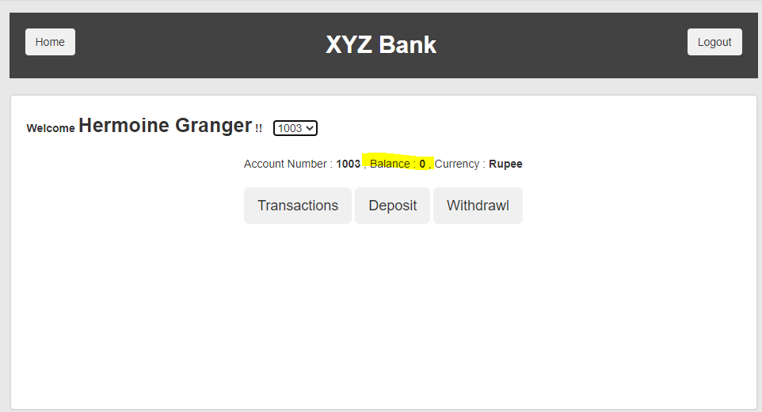

**Q3(MANDATORY)**

**Candidate will be asked to demo their solution during the interview.**

The User APIs has just been updated. Please perform the following test flow on the following endpoints. (<https://petstore3.swagger.io/#/user>)

Perform the following flows:

* Create a new user
* Read the created user
* Update the user’s username
* Read the updated user
* Delete the user
* Verify the user is deleted